**How to install and set up Jenkins**

Step1 --

Click on first link

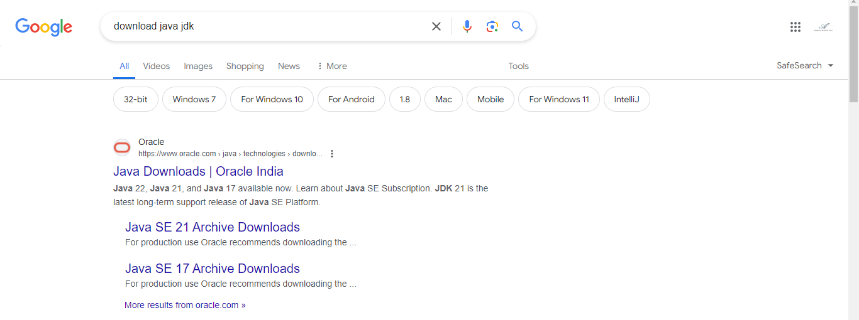

x64 MSI Installer (<https://download.oracle.com/java/21/latest/jdk-21_windows-x64_bin.msi>)

After installation check either Java is installed or not in command prompt

java -version

This command will display the version of Java installed on your system.

Step2 –

**Jenkins download and deployment**

While installing select windows for local machine and while installing on Virtual machines select Ubuntu/Debian

After completion of installation process for both Java & Jenkins .

* Go to the edit the system environment variables in search in windows
* Click on environment variables

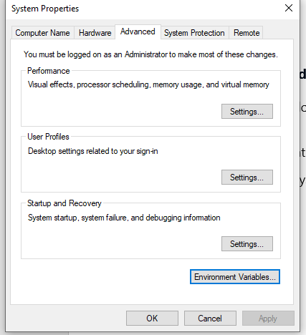

After clicking on environment variables give the path where java is installed

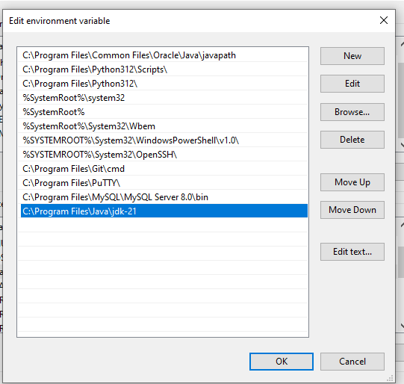

After setting up all the requirements go to the google chrome page and type localhost:8080

Jenkins local dashboard will be open.

Login into the Jenkins Dashboard by giving Username & Password.

* Installed Required Plugins for project environment
* In the Dashboard on the left side bar click on manage Jenkins
* Create Node give the necessary Remote root directory path

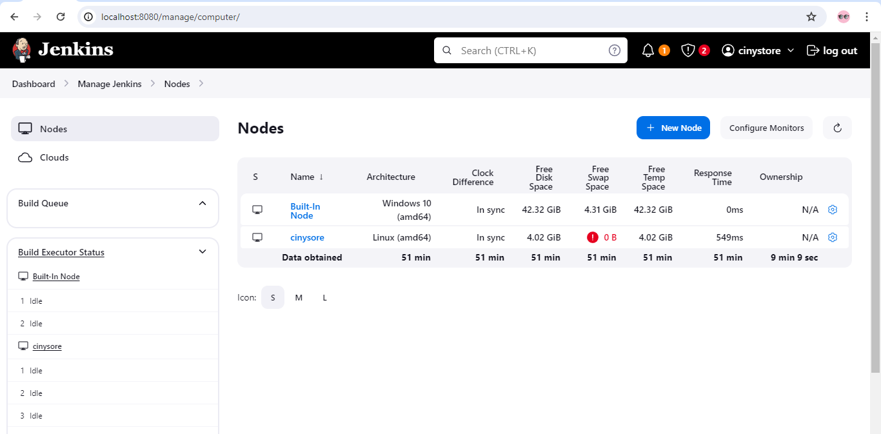

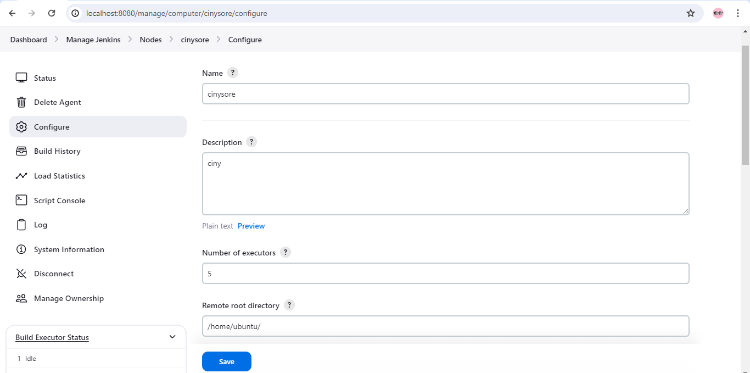

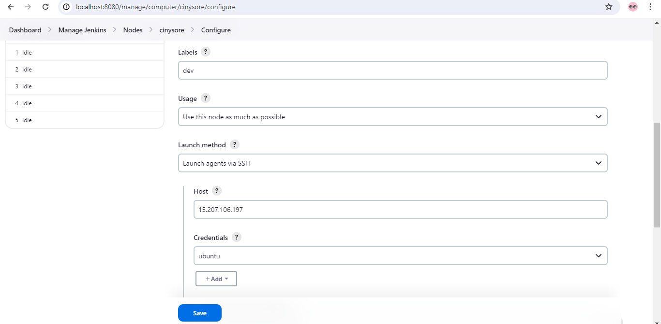

After creating node then test either it is connected or not.

* And Create a new item as per given below screenshot

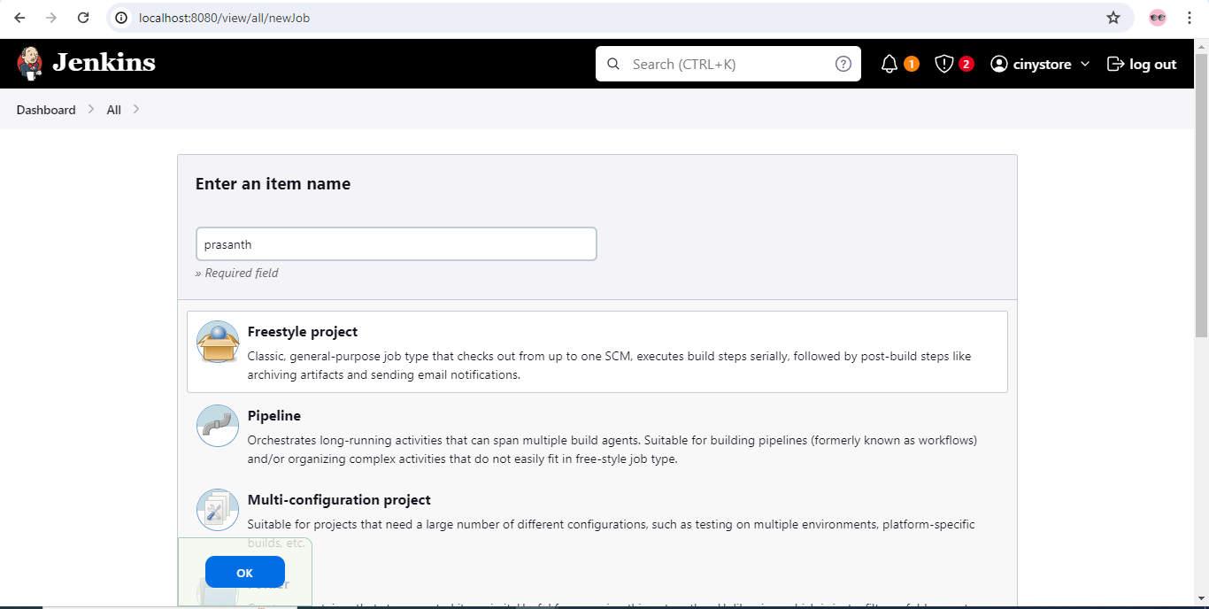

And after creating an item please go to the that and on left side bar click on configure

In the Build steps {For windows select}   
**Execute Windows batch command**

{For Linux/VM machines}

**Execute shell**